§
Lab07: Introduction to Prolog and Sample Program

Exercise

1.Covert following sentences in to PROLOG FACTS and specify whether they represent RELATIONSHIP or PROPERTY:
Declarative Sentence | PROLOG FACT | RELATIONSHIP or PROPERTY
SSUET is university | university(SSUET). | Relationship
Faheem likes ice-cream | likes(Faheem, ice-cream). | Property
Birds can fly | fly(Birds). | Property
Switch is off | off(switch). | Property
Sara is enemy of saima | enemy(Sara, Saima). | Relationship
2. Clauses:
We create a file named task.pl.

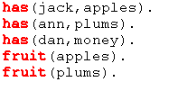
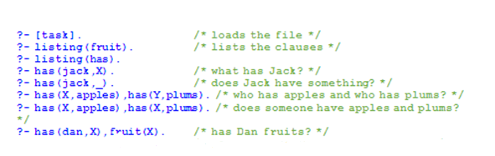
Task: Execute Above Code
SOURCE CODE:
has(jack, apples).
has(ann, plums).
has(dan, money).
fruit(apples).
fruit(plums).

OUTPUT:
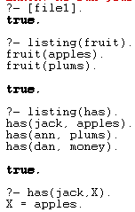
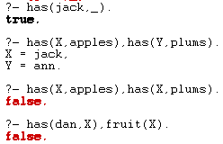
3. Make prolog facts from following sentences and answer the questions by typing queries on prolog.
Saleem is father of aslam
Dania is mother of aslam
Aslam and saeed are brothers
Faria is sister of arham
Sara is enemy of simra
Questions
List brother.
Who is father of aslam?
Dania is mother of whom?
Who is brother of aslam?
Faria is sister of whom?

SOURCE CODE:
father(saleem, aslam).
mother(dania, aslam).
brothers(aslam, saeed).
sister(faria,arham).
enemy(sara,simra).

OUTPUT:
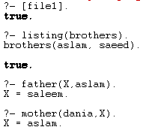
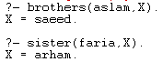

4. A person gets good grades if he studies well and is regular in class. Write program in prolog to check whether a given person gets good grade or not?
SOURCE CODE:
studies(anush).
studies(mariyum).
studies(talha).
regular(mariyum).
regular(talha).
goodgrade(X):-studies(X),regular(X).

OUTPUT:
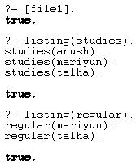
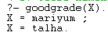
5. Here are some declarative sentences convert them into PROLOG facts and answer following questions.
Kashif likes music.
Kashif likes cricket.
Sara likes chips.
Sara likes mobile.
Kashif hates cold drinks.
Sara hates driving.
Sara hates parties.
Questions (GOALS):
Does Sara like chips?
Does Kashif hate cricket?
Does Kashif like music?
What does kashif like?
What does Sara like?
Who likes music?

SOURCE CODE:
likes(kashif,music).
likes(kashif,cricket).
likes(sara,chips).
likes(sara,mobile).
hates(khasif,drinks).
hates(sara,driving).
hates(sara,parties).

OUTPUT:
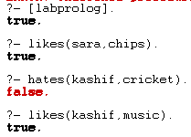
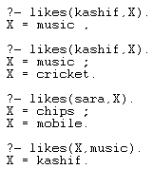
6.Cricket case study
There is a cricket team of 5 players; capabilities (properties) of each of the player are given in following table.
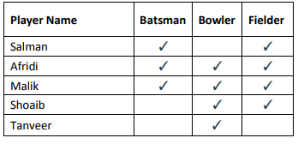
Write the facts from the above table, create the rule for all Rounder and run following goals in PROLOG.
1. Is Afridi all rounder?
2. Is Shoaib all rounder?
3. Who are all rounders in the team?

SOURCE CODE:
batsman(salman).
batsman(afridi).
batsman(malik).
batsman(shoaib).
batsman(tanveer).
bowler(afridi).
bowler(malik).
bowler(shoaib).
bowler(tanveer).
fielder(salman).
fielder(afridi).
fielder(malik).
fielder(shoaib).
allrounder(X):-batsman(X),bowler(X),fielder(X).

OUTPUT:

